1. Use SAPLink to install the program.

NUGG_ABAPGIT V1.80.nugg

1. SSL setup
   1. download certificate
      1. On chrome, go to <https://github.com>



* + 1. Click on the locker near the address bar, then click on “Details”



* + 1. download the first and second cer.

1. Config SSL use SAP GUI

Install the certificates in STRUST transaction

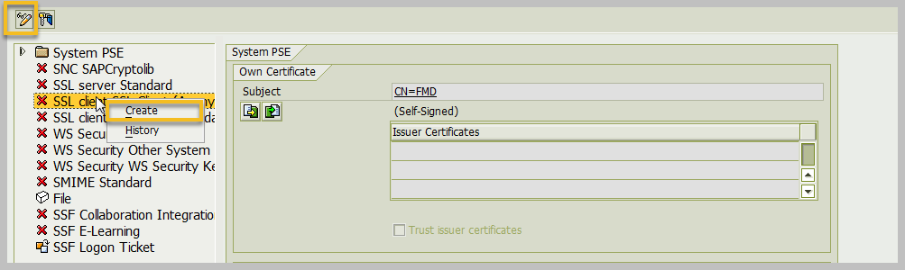

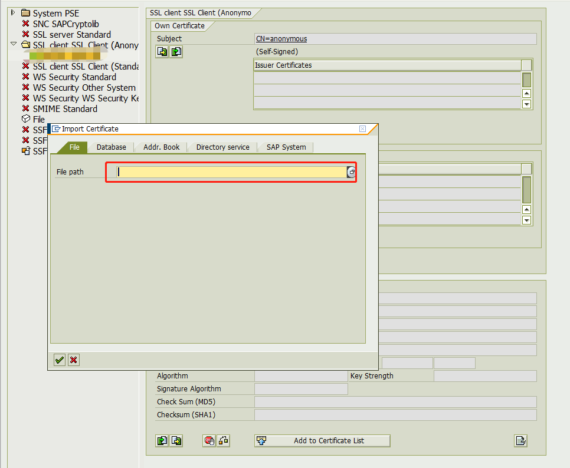

Finished like this

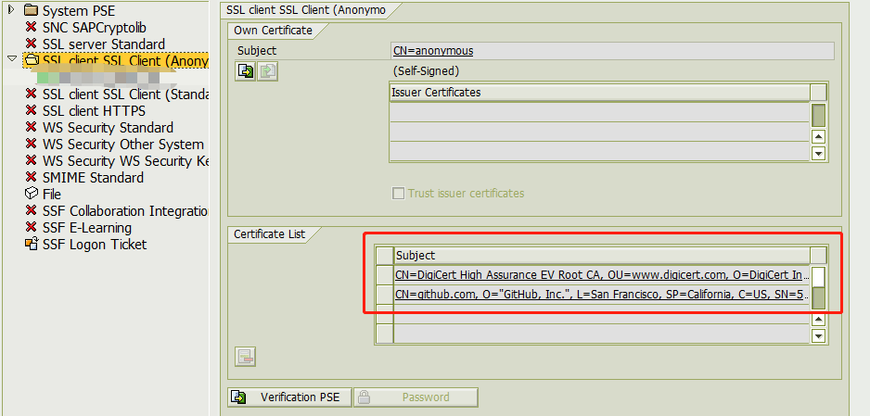

1. Add profile parameters

Transaction RZ11 add profile parameters, and restart sap application.

ssl/client_ciphersuites = 150:PFS:HIGH::EC_P256:EC_HIGH

ssl/ciphersuites = 135:PFS:HIGH::EC_P256:EC_HIGH

1. Test SSL

Transaction SE38, ZABAPGIT_TEST_SSL , the program you have installed before in nugg file.

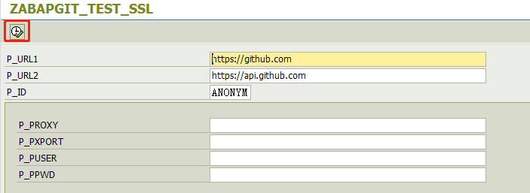

Result like this, bingo, success

